Types of Homonyms
# Source: AI Source: Provided by: [Data Path: Persons Table -> ID Column: 1, Name_En Column: Motasem Essam] -> From: [ChatGPT] on [8/1/2025]
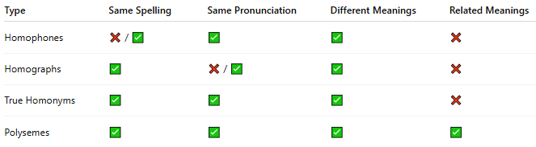

Type | Same Spelling | Same Pronunciation | Different Meanings | Related Meanings
Homophones | ❌ / ✅ | ✅ | ✅ | ❌
Homographs | ✅ | ❌ / ✅ | ✅ | ❌
True Homonyms | ✅ | ✅ | ✅ | ❌
Polysemes | ✅ | ✅ | ✅ | ✅

